**Lab 10 – Plotting in MATLAB**

1. **shows how to plot more than one line by passing multiple x, y pairs to the plot function. Define y1 and y2 as sine waves with a phase shift. (y1=sinx, y2=cosx)**

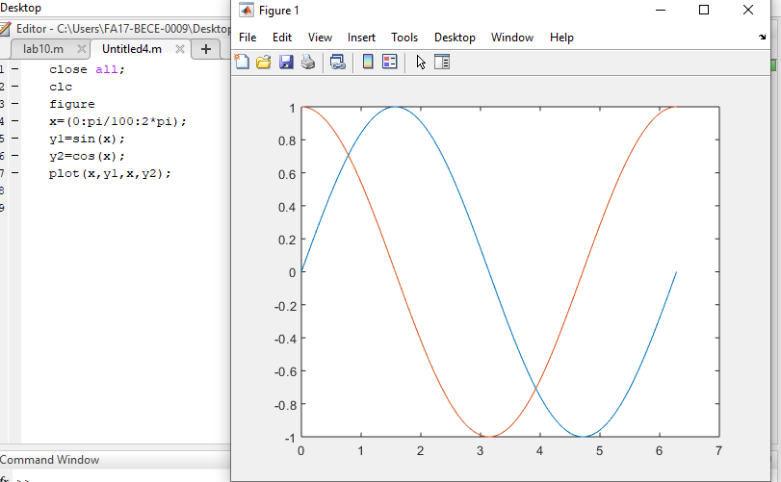

1. **shows how to plot two sine waves with different line styles by adding a line specification string to each x, y pair. Plot the first sine wave with a dashed line using '--'. Plot the second sine wave with a dotted line using ':'. (hint: plot (x, y1,'--', x, y2,':'))**

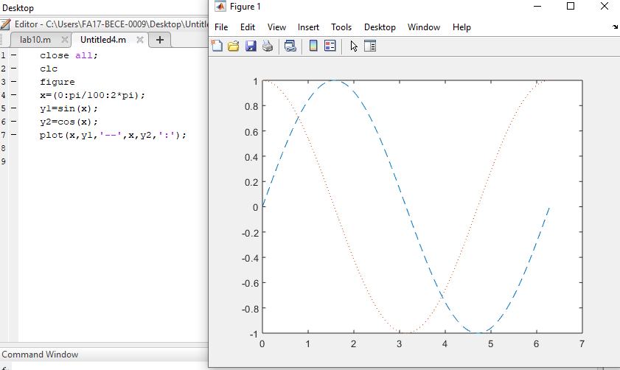

1. **shows how to specify the line styles and line colors for a plot. Plot a sine wave with a green dashed line using '--g'. Plot a second sine wave with a red dotted line using ‘: r'. The elements of the line specification strings can appear in any order. using subplot**

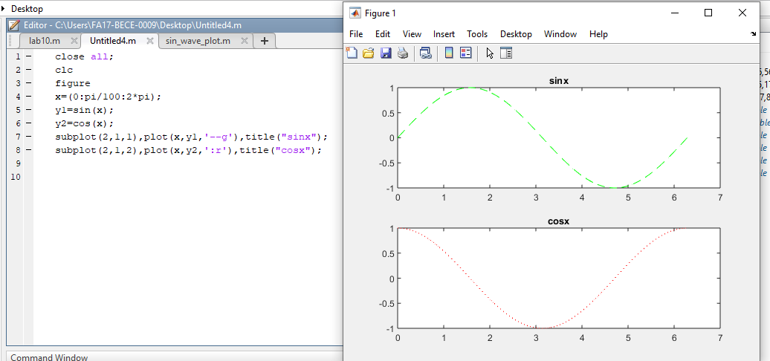

## Exercise

Create an m-file as follows (note that MATLAB uses angles measured in radians):

% sine_wave_plot.m

% Created by “YOUR NAME” on “TODAY’S DATE” clear

x=[0:0.01:4*pi];

y=sin(x);

plot(x,y)

title('Plot of a Sine Wave')

ylabel('y values')

xlabel('x values')

grid on

figure(gcf)

**Be sure that the screen shows all three parts:**

1. The Script (.m) file.
2. The Command Window, showing that you ran the Script file.
3. The Plot Window, showing the plot.

